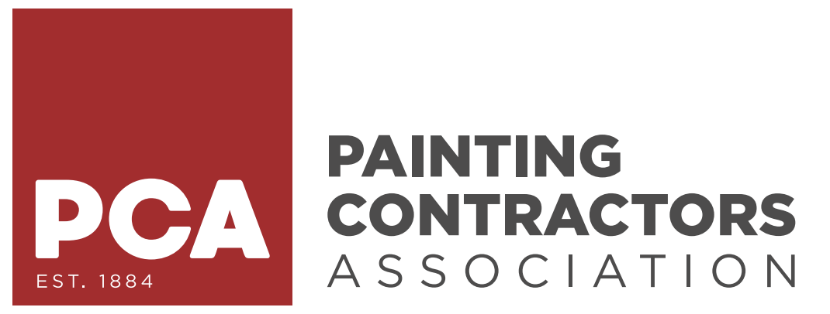
Quick Guide:
Planning A Successful
Paint It Forward Event

“To change the world, you must share your impact to influence others”

6-9 Months Prior To Event
☐ Choose & notify recipient (Make notification special)
☐ Choose date of event & how long project will take
☐ Determine scope of work with recipient (What is their Wishlist?)
☐ Identify company budget (What you’re willing to spend)
☐ Identify project budget (The value of the job you want to accomplish)
☐ Assign roles and responsibilities within your organization
☐ Register your event with the PCA
☐ Secure location for after-event banquet
☐ Start recruiting volunteer companies (local painting companies, subcontractors)
☐ Start recruiting volunteers (non-painters can be assigned non-painting tasks)
☐ Post PIF badge (received from PCA after registering your event) on website/social media accounts
☐ Start talking locally/on social media about your PIF event using the PIF social media package (provided by PCA after registering your event)

3-5 Months Prior To Event
☐ Set up monthly planning meetings with recipient
☐ Create sponsorship form–start reaching out to local businesses for event sponsorship (help fund banquet, shirts, banners, breakfast, lunch, etc.)
☐ Reach out to local plaque company for volunteer/sponsor plaque donation
☐ Create your personalized event logo (for volunteer t-shirts/sponsorship form)
☐ Secure t-shirt company/order volunteer shirts (make them a sponsor)
☐ Create sponsorship/volunteer banners & signage to display day of event
☐ Secure paint donation–using the PIF Manufacturer’s Letter provided by PCA after registering your event (SW or BM)
☐ Secure photographer/videographer for day of event/banquet (make them a sponsor)
☐ Reach out to local media outlets to advertise your event
☐ Define equipment necessary and start coordination of equipment gathering
☐ Define materials necessary and start coordination of material gathering
☐ Contact Sherwin Williams and/or Benjamin Moore to start process of paint donation
☐ Secure muralists or vinyl company to add a personalized touch

1-2 Months Prior To Event
☐ Plan breakfast/lunch for volunteers on event date
☐ Confirm paint donation paperwork (including colors, sheens, quantities, etc.)
☐ Create a plan for banquet speeches/plaque ceremony
☐ Think communication (if radios can be obtained – streamline operations)

2 Weeks Prior to Event
☐ Have final walk-thru/planning meeting with recipient
☐ Create an Event Day Itinerary–this can be given to volunteers as they check in for the day
☐ Create a volunteer check-in list to be used at registration table on day of event
☐ Stuff banquet ticket envelopes–to be given to volunteers/sponsors morning of event at registration table
☐ Have liability waiver for volunteers to sign releasing company and recipient of injury liability

1-2 Days Prior to Event
☐ Paint/material delivery
☐ Send crew to prep (pre-event prep work will allow for a smoother and quicker operation – ultimately allowing much more painting to be accomplished)

Day of Event
☐ Set up registration table–volunteer check-in, t-shirt distribution & banquet tickets given out, liability waivers signed
☐ Morning conference with all volunteers (motivation speech, scope of work)
☐ Divide crews into teams/floors for project execution
☐ Take event photos/videos throughout the day
☐ Final walk-thru to insure completion
☐ Clean up & disposal
☐ Attend after-event banquet to celebrate your and the volunteers’ efforts
☐ Have fun and know you are making a difference!
☐ Embrace your new lifelong relationships!

Have your videographer make a summary video! All involved will cherish the
impact and love to share and re-watch this video. Embed video to all your platforms–Return on Community Investment (ROCI).
